CS 505 Module Two Activity Template

Set Theory Calculations
- Determine the number of elements in the following sets:
  - {{a, b, {a, b}, {a, c}}}
There is one element, a set with the following four elements: a, b, a set containing a and b, and a set containing a and c.
  - {{}, {{}}, {{{}}}}
There are three elements: the empty set, a set containing the empty set, and a set containing a set containing the empty set.
  - {a, b, {}, {{{}}}}
There are four elements: a, b, the empty set, and a set containing a set containing the empty set.

- List the members of the following sets:
  - {x|x is a positive integer less than 10}
The set contains 1, 2, 3, 4, 5, 6, 7, 8, 9.
  - {x|x is a real number such that x² = 4}
This set contains 2 and -2.
  - {x|x is the square of an integer and x < 200}
This set contains, 1, 4, 9, 16, 25, 36, 49, 64, 81, 100, 121, 144, 169, 196.

- Consider the following sets and determine whether each of the following statements is true or false:
A = {2, 3, 5, 9, 10}
B = {3, 5, 8}
C = {2, 6}
U = {0, 1, 2, 3, 4, 5, 6, 7, 8, 9, 10}
  - 8 ∊ B
True, 8 is an element of B.
  - B ⊂ A
False, as 8 is not an element of A.
  - C ⊂ A
False, as 6 is not an element of A.
  - 2 ∊ C
True, 2 is an element of C.
  - C ⊂ B
False, as neither 2 nor 6 are elements of B.
  - C ⊂ U
True, both 2 and 6 are elements of U.

Set Theory Rationale
- Let A = {1, 2, 3, 4}, B = {1, 2, 6}, and C = {2, 4}. Answer each of the following questions:
  - Is B ⊆ A?
No, because 6 is not an element of A.
  - Is C ⊆ A?
Yes, because both 2 and 6 are elements of A.
  - Is C ⊆ C?
Yes, because C is equivalent to itself.
  - Is C a proper subset of B?
No, because 4 is not an element of B.

- Explain whether each of the following is a well-defined set:
  - The collection of cardinal directions.
Yes, because there are only four cardinal directions.
  - A collection of interesting stamps.
No, because ‘interesting’ is not defined and depends on the person.
  - The collection of all real numbers x for which 3x − 9 = 18.
Yes, because only one real number satisfies the condition.
  - The collection of all integers x for which 5x − 10 = 3.
Yes, because only one integer satisfies this condition.
  - The collection of all terrible basketball players.
No, because ‘terrible’ is not defined and depends on the person.

Set Operations and Cardinality Calculations
- Find the number of elements in the set {3, 12, 15, 25} and then use the formula for the cardinality of a power set to find the cardinality of P ({3, 12, 15, 25}).
The set has 4 elements, and the cardinality of a power set is 2^{n} for n elements. Therefore, the cardinality of this power set is 16.

- Find the union of two sets: A = {2, 5, 9, 11} and B = {2, 5, 11, 25}.
The union of A and B is {2, 5, 9, 11, 25}. The elements 2, 5, and 11 are contained in both sets, so we do not count them twice.

- Find the intersection of sets P = {5, 6, 9, 11} and Q = {6, 11}.
The intersection of P and Q is Q, since Q is a proper subset of P.

- Find the complement of set X = {p, r, s} where universal set U = {e, f, h, p, r, s}.
The complement of X in U is {e, f, h}. The complement of X is all elements in the universal U that are not contained in X.

- Given two sets A = {1, 3, 4, 7, 10} and B = {1, 3, 8, 15}, find B − A.
The set difference of B and A is {8, 15}. The elements 1 and 3 are in both sets, so we disregard them. Since we are removing all elements of A that are contained in B, then we ignore 4, 7, and 10, since they are not contained in B.

- Consider the following sets:
A = {pink, green, blue}
B = {pink, purple, orange}
C = {pink, orange, purple, green, blue, red}
Determine each of the following:
- Find A ⋃ B.
{pink, green, blue, purple, orange}
Pink is in both sets, so we don’t count it twice.
- Find A ⋂ B.
{pink}
Only pink is in both sets.
- Find A^{c} ⋂ C.
{orange, purple, red}
The complement of A is all elements not in A, so we consider all the elements of B and C not in A. This removes pink, green, and blue. Then we intersect this with C, leaving us with three elements.

- Consider the following sets:
H = {cat, dog, tortoise, fish}
F = {dog, cow, duck, pig, rabbit}
W = {duck, tortoise, deer, frog, fish}
Determine each of the following:
- (H ⋂ F) ⋃ W
{dog, duck, tortoise, deer, frog, fish}
Only dog is in both H and F, and we then union that with W.
- H ⋂ (F ⋃ W)
{dog, tortoise, fish}
We take the union of F and W, giving us a total of 9 elements, then intersect with H, leaving us 3 elements.
- (H ⋂ F)^{c} ⋂ W
{tortoise, fish, duck}
As seen before, only dog is in the intersection of H and F, but we then take the complement of that, so everything H and F do not share. Then we intersect that with W, giving us only 3 elements.

Set Operations and Cardinality Rationale
- Let A, B, and C be subsets of a universal set U. For each of the following, draw a Venn diagram for three sets and shade the region(s) that represent the specified set.
- (A ∩ B) ∩ C
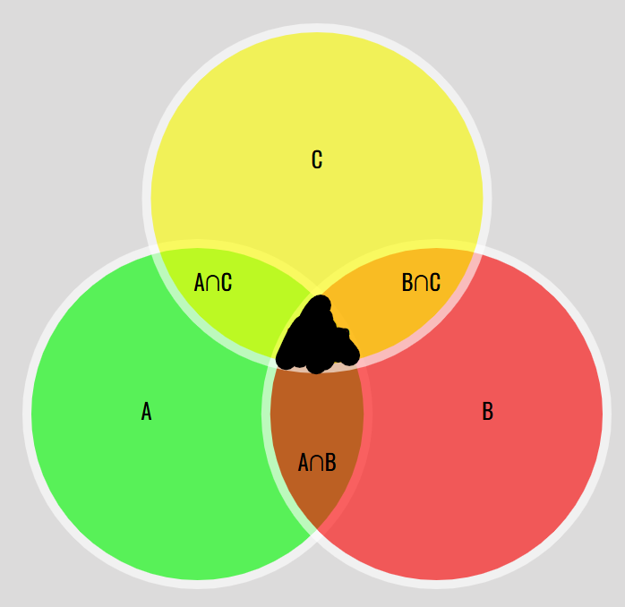
This region is the area all three sets must share.
- (A ∩ B) ∪ C
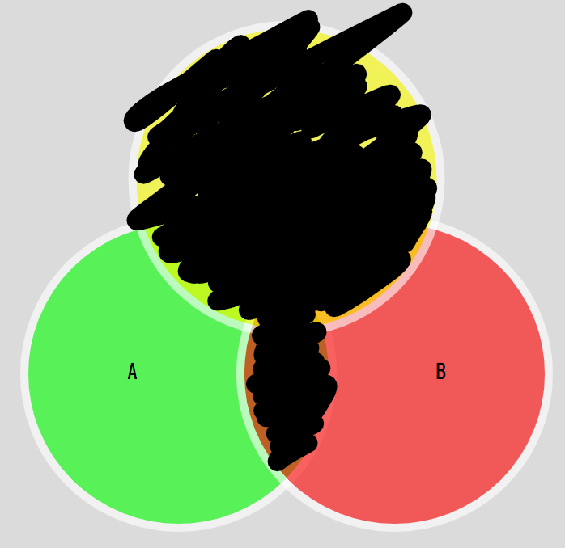
We consider the area both A and B share, and union that with all of C.
- A^{c} ∩ (B ∪ C)
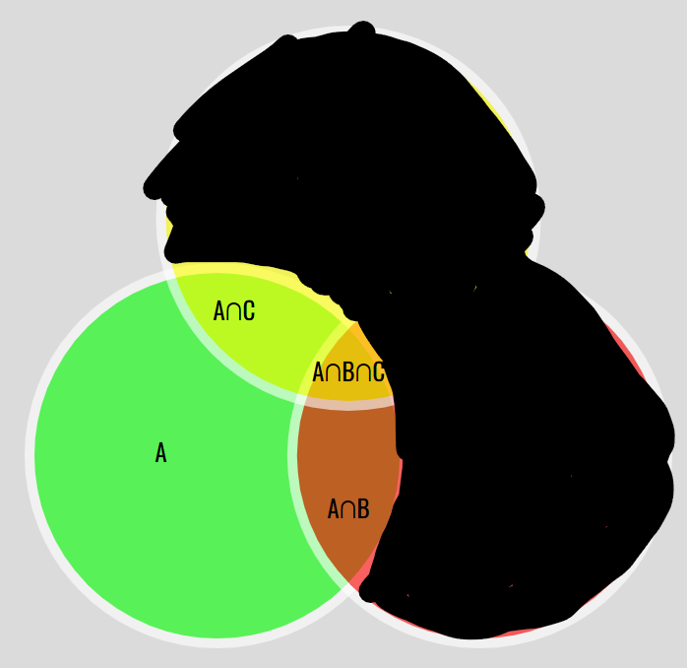
We take the union of B and C, then intersect it with the complement of A, so we lose everything shared with A.

- Let A = {1, 2, 4}, B = {1, 2}, C = {0, 5, 9}, and let the universal set be U = {0, 1, 2,... 9}. Determine each of the following:
- A ∩ B
{1, 2}
Since B is a proper subset of A, then their intersection is B.
- A ∪ B
{1, 2, 4}
Since B is a proper subset of A, then their union is A.
- A ∪ C
{0, 1, 2, 4, 5, 9}
The two sets don’t share any values, so their union contains all the values without repeats.
- A – B
{4}
The set difference of B from A is all the values in A that are not in B, so just 4.
- A^{c}
{3, 5, 6, 7, 8, 9}
The complement of A in the universal U contains all values not in A.
- C^{c}
{1, 2, 3, 4, 6, 7, 8}
Like the previous problem, the complement of C in U is all values in U not in C.

- Illustrate the following sets in a Venn diagram, marking all the elements in the appropriate places:
U = {1, 2, 3, 4, 5, 6, 7, 8, 9, 10}
A = {2, 4, 6, 8, 10}
B = {1, 3, 6, 7, 8}
C = {3, 7}
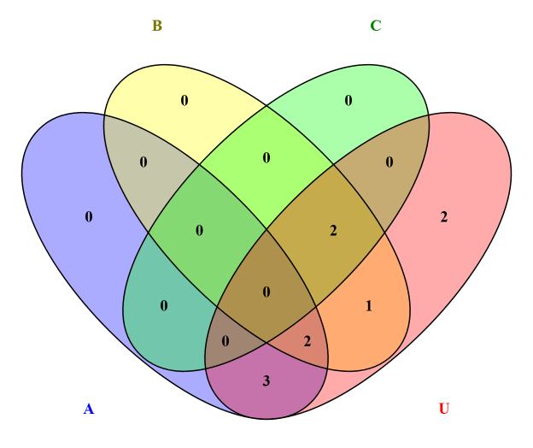
- Using your Venn diagram, list the elements in each of the following sets:
    - A ∩ B
{6, 8}
The values of A are all the even integers of U, and B contains two even integers, so their intersection is just those integers.
    - A ∪ C
{2, 3, 4, 6, 7, 8, 10}
The union combines the two sets.
    - B ∩ A^{c}
{1, 3, 7}
The complement of A is all odd integers, and B has three such integers, so the intersection is those three integers.
    - B ∩ C^{c}
{1, 6, 8}
The complement of C is everything but 3 and 7, and since C is a proper subset of B, then the intersection is the set difference of C from B.
    - C – B
{}
Since C is a proper subset of B, then the set difference of B from C is empty.

Sets can both be very simple and very complicated. In the everyday world, most people directly deal with very simple sets. For example, a person’s salad for lunch has a few different food items in it, which make up a ‘salad set’ or maybe the salad itself is part of a ‘lunch set.’ In mathematics, we learn about natural numbers, integers, and real numbers, all of which are sets of numbers. The definition of the real numbers is not exactly defined consistently in math, and real analysis describes it far more deeply than needed here (Schechter para. 2). But fundamentally, we know it contains the simpler sets of integers and natural numbers. These sets are used more often in the real world. For example, if one wanted to count how many fruits are in a bowl, you would use natural numbers.
Mathematically, we can discuss the relations between these sets. Natural numbers are a proper subset of the integers, and we write this as ℕ⊂ℤ. Every natural number is an integer, but not every integer is a natural number. Then, we also know that ℤ⊂ℝ: every integer is a real number, but not every real number is an integer. It also means that ℕ⊂ℝ, or that every natural number is real, but not every real number is a natural number. On a larger scale, we may consider the rational numbers ℚ. The rationals are also contained in the reals, but not every real is rational. Irrational numbers make up the rest of the reals, and we can define this as ℚ∪ℚ^{c}=ℝ. In other words, the union of the rationals and the complement of the rationals within the reals is the real numbers. A set plus the complement of that set makes up the entire ‘universal’ set we are working with. Of course, this comes with defining what the ‘universal’ set is, which in this case was the reals. Otherwise, we could have said the complement of the rationals was all irrational numbers and all numbers with an imaginary component. The ‘universal’ set in that scenario is ℂ. Along with complements, we could also have said ℝ-ℚ=ℚ^{c}, which means that the set difference of the rationals from the reals is the complement of the rationals. We could have just as well said ℝ-ℚ^{c}=ℚ. It also means that ℚ∩ℚ^{c}=Ø, or that the intersection of the rationals and its complement is empty. There are no values shared between them.
In basic programming, we learn about lists and dictionaries, both mutable sets in Python. A list ‘automatically grows and shrinks’ with methods (GeeksforGeeks para. 2). A list is itself a set, as it contains values, such as integers, floats, strings, and even more lists. In that sense, it is a set that can contain another set. The only difference from mathematical sets is that lists can contain any type of value simultaneously. One value is a string, another a float, another a list, and so on. There is no specific restriction on what it can contain, or even repeated values. A dictionary, while not restricting different types of keys, disallows repeated keys. In a sense, a dictionary also acts like a surjective function. A given key takes you to some other value, which can be repeated among keys. Every value can be mapped back to a key.
A set is also a distinct object in Python too. For example, taking a set x = {1, 2, 3} and another y = {3, 4, 5} can be unioned as x | y, while the intersection is x & y (Pant para. 7). We can use the social media scenario provided. There is a set of Facebook users: {Alice, Bob, Charlie, David}. If Alice and Bob are friends, this is considered a symmetric relation: Alice is a friend of Bob, and Bob is a friend of Alice (Pant para. 10). We could also say every friend of Bob is friends with each other, so if Alice and Charlie are both Bob’s friends, then they are also friends of each other: a transitive relation. We could also say Bob is friends with himself (since he knows himself), so that is a reflexive relation. Using set operations of this set along with other sets can give us more relations, such as ‘People You May Know’ (Pant para. 13). Unioning with a set of users in another network expands the number of possible people to be connected to. An intersection may tell us the person that is in both social networks. A set difference tells us the people in only one network. Or maybe in a universal set of social media users, one subset is only Facebook users, everyone else on Instagram, so the complement of Facebook users is Instagram users.
These operations matter in the real world, because they describe the connections people have and can have with each other. By intersection of two friend groups, we find the person shared among them, so then each group is recommended to connect with the other. The union of influencers followed by a group shows all influencers followed. The set difference of that union and one person’s following shows the influencers not followed, and they will be recommended to that user because their friends do. As we can see, sets matter significantly in the development of social media networks, arguably the foundation of social networks, where set operations define how networks can change.
Sources:
Schechter, E. (n.d.). What are the “real numbers,” really? Vanderbilt Department of Mathematics. https://math.vanderbilt.edu/schectex/courses/thereals/
GeeksforGeeks. (2025, July 12). Difference between list and dictionary in Python - GeeksforGeeks. GeeksforGeeks. https://www.geeksforgeeks.org/python/difference-between-list-and-dictionary-in-python/
Pant, R. (2025, August 19). Beyond memorization: Understanding set theory and relations in Real Life & Computer Science | by Rachita Pant | Medium. Medium. https://medium.com/@rachitap89/beyond-memorization-understanding-set-theory-and-relations-in-real-life-computer-science-f3e55df924d9

